- VATA SSATC Winter Symposium 2020  Registration: https://www.vata.us/ssatc-2020-winter-symposium  Program Details (Full Agenda here)  Christy Eason, Ph.D, ATC  Work / Life Balance  Janet E. Simon, PhD, ATC  HRQOL  Nicki Favero, PsyD, LCP  Return to Play Anxiety  Jon Macaskill  Mindfulness and Meditation  Dr. Jim Afrenow, P.hD.,LPC  Cognitive Reframing  Angela White MS, LAT, ATC  AT’s Care  Nina Walker, MA, LAT, ATC  Mental Health and the Sports Medicine Provider  Kate Jochimsen, PhD, ATC  Part 1: The impact of poor psychosocial health on injury outcomes  Part 2: Evidence-based interventions for improving psychosocial health in the athletic training setting  Jennifer Armstrong, MS, LAT, ATC  VHSL Update and COVID-19 Information for the SSATC in VA  OBJECTIVES:  The 2020 SSATC Winter Symposium will:  - Identify the individual and organizational factors that can contribute negatively or positively to one’s work-life balance  - Implement strategies to evaluate patient-reported outcomes in clinical practice.  - Learn strategies to help athletes manage return to play anxiety  - Explain the impact of poor psychosocial health on pain and functional outcomes following injury  - Describe the evidence supporting interventions for improving poor psychosocial health in the athletic training setting  - Provide sport medicine providers with general information about mental health continuum  - Discuss how cognitive reframing is used in mental health and peak performance  - Explain the concepts of mindfulness and meditation  - Identify “good” stressors from “bad” stressors  - Review examples of COVID-19 policies and procedures and discuss specific VHSL updates  *Program Agenda Subject to Change* | 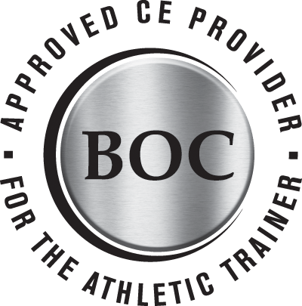  VATA (AP#344) is approved by the BOC to provide continuing education to AT’s. This program is eligible for a maximum of 10.0 CAT A Hours. AT’s should only claim those hours spent in educational program  Virtual, Pre-Recorded Webinars available from Dec 2 – Dec 7th  Registration is only $10 for 8.0 Cat A CE’s!  Registration open until Dec 1  Please contact SSATC Chair, Jen Armstrong at vatassatcchair@gmail.com with any questions!  Cancellations must be received no later than Nov. 25, 2020 and emailed to Jen Armstrong (vatassatcchair@gmail.com). Registration refunds will not be given if received after the deadline. Refund requests must be sent in writing to the VATA (vatatreasurer@gmail.com) and will be processed no later than eight weeks after the last day of the meeting

